Cotton Australia
Primary School Posters with Australian Curriculum Links

From Field to Fashion Poster

The Field to Fashion poster supports research and investigation for a unit on food and fibre. It clearly follows the process involved from growing and picking cotton fibre, exporting and all the steps involved to produce a cotton t-shirt. Each step is illustrated with an easy to decipher description of the process.

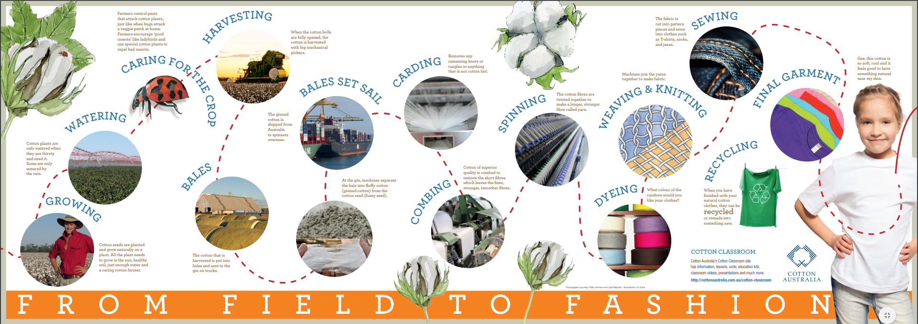
https://cottonaustralia.com.au/assets/general/Education-resources/Posters/Field-to-Fashion-Primary-poster-ONLINE.pdf

Foundation to Year 2: Design and Technologies. Explore how plants and animals are grown for food, clothing and shelter and how food is selected and prepared for healthy eating (ACTDEK003)

Year 3 to Year 4: Design and Technologies. Investigate food and fibre production and food technologies used in modern and traditional societies (ACTDEK012)

Year 4 to Year 6: Design and Technologies. Investigate how and why food and fibre are produced in managed environments and prepared to enable people to grow and be healthy (ACTDEK021)
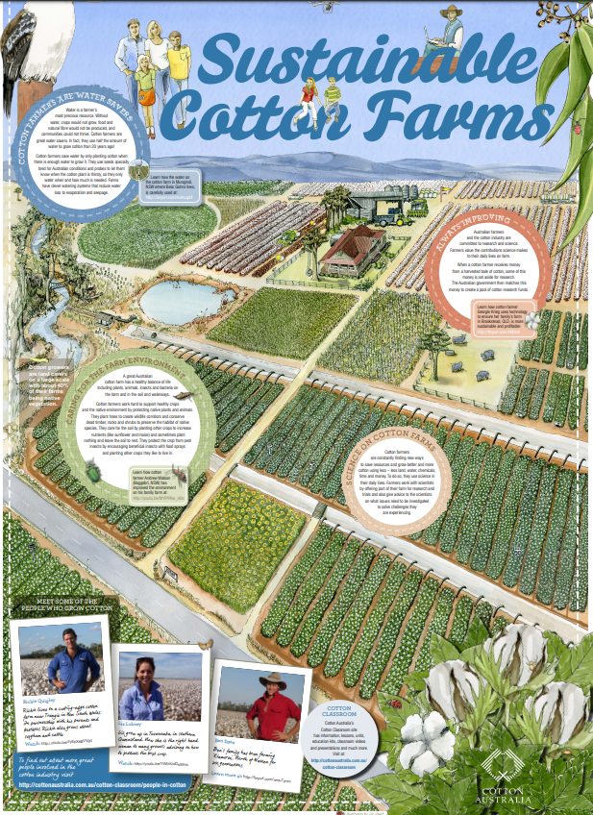
https://cottonaustralia.com.au/assets/general/Education-resources/Posters/Sustainable-Cotton-Farm-A1-Poster-Primary-Online.pdf

Sustainable Cotton Farm Poster
The Sustainable Cotton Farm Poster supports Science, Technology and Geography outcomes related to food and fibre units of work. The poster clearly demonstrates cotton is a plant fibre grown in a managed environment and highlights many of the aspects that a farmer considers when producing world class sustainable fibres and how they care for the environment.
- Year 1: Science. Living things live in different places where their needs are met (ACSSU211)
- Year 2: Science. People use science in their daily lives, including when caring for their environment and living things (ACSHE035)
- Year 3: Science. Living things can be grouped on the basis of observable features and can be distinguished from non-living things (ACSSU044)
- Year 4: Science. Living things, depend on each other and the environment to survive (ACSSU073)
- Year 5: Science. Scientific knowledge is used to solve problems and inform personal and community decisions (ACSHE083)
- Year 6: Science. The growth and survival of living things are affected by the physical conditions of their environment (ACSSU094)

Where is Cotton Grown Map
The Where is Cotton Grown Map illustrates locations in Australia that cotton is grown. The map supports students research in food and fibre units of work and hints at further work on why these locations are best for growing cotton.
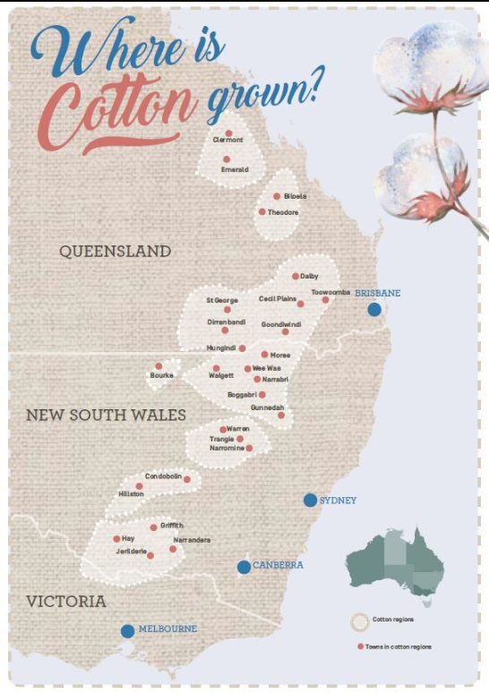
https://cottonaustralia.com.au/assets/general/Education-resources/Posters/Cotton-Map-poster-ONLINE.pdf

- Foundation to Year 2: Design and Technologies. Explore how plants and animals are grown for food, clothing and shelter and how food is selected and prepared for healthy eating (ACTDEK003)
- Year 3 to Year 4: Design and Technologies. Investigate food and fibre production and food technologies used in modern and traditional societies (ACTDEK012)
- Design & Technologies – Stage 3 Investigate how and why food and fibre are produced in managed environments and prepared to enable people to grow and be healthy (ACTDEK021)

