Cotton STEAM Infographic Challenge - Investigating cotton products
Years 5-10
Cotton is all around us every day. We wake up in cotton bed sheets, wash using soap containing cotton oil, dry ourselves using a cotton towel, dress in cotton clothing, eat cereal manufactured using cotton oil, and dry our bowl with a cotton tea towel. The car you drive has cotton in the tyres and seats and the list goes on.
Cotton is one of the oldest known natural fibres. Yet, when you search the internet for one concise infographic about all the products made from cotton lint or with cotton by-products on the world wide web – your results are limited. The Cotton Australia website can help with some facts (https://cottonaustralia.com.au/uses-of-cotton) and just one example can be found on the Sustainable Cotton Cluster’s website. It is a USA non-profit company that provides information about cotton and there is one simple infographic, Products Made from Cotton (https://sustainablecottoncluster.wordpress.com/2016/02/25/the-many-many-uses-of-cotton/).
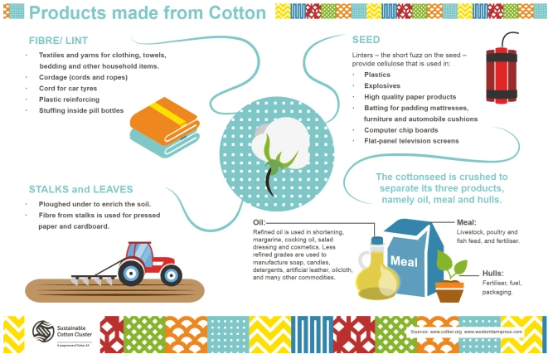
You might be surprised to find explosives, computer boards and flat screen TVs all use cotton by-products and you can even find cotton in space.
Challenge yourself to write down all the things that are made using cotton before researching. It’s good to revisit this to reflect on your discoveries.
It is useful to know that cotton is both a food and a fibre crop. While its widely known cotton lint is in our clothes, home furnishings, personal health and hygiene products, less is known about cottonseeds that are just as useful and almost as valuable as livestock feed or oil.
The Challenge
The challenge is to create an infographic showing all the uses of cotton. The information should include products made from the fibre/lint, the cotton seed and the cotton plant itself including stalks, leaves and cotton ‘trash’, which is a by-product of ginning. Your infographic will have both text and drawings or images that are free to use. Your information should be appropriate for school-aged children and can target either primary or secondary year groups.
Please feel free to share your finished products with Cotton Australia directly at talktous@cotton.org.au or tag @CottonAustralia in any posts on social media but only after gaining approval from your teacher. Outstanding posts may be showcased in Cotton Australia’s education program teaching students about cotton fibre.
Infographic Guidelines
Create your infographic on a poster using any medium and then photograph to share or create it digitally using trusted software.
Think about how to present your researched information for your target audience and use a layout and images they can easily relate to and consider using a limited colour pallet and fonts. Remember, your goal is to educate your target audience about the amazing uses of cotton in their everyday products.
You can watch a YouTube video to learn how to use Google Drawings https://www.youtube.com/watch?v=71dJAOtb3S8
You can use Canva for inspiration https://www.canva.com/create/infographics/
You can watch cotton growers talk about the cotton products they produce https://www.youtube.com/watch?v=3TW3osxL1fM
Good luck! For further information please email: jennyh@cotton.org.au

