Gateway Schools to Agribusiness
Career Pathways into the Cotton Industry
Classroom resources

Water — waste not, want not

Year 7 Science

January 2013

Authors:

Dianne Fullelove South Region Coordinator
Sally Bidstrup, Teacher & Cotton grower
Mobile: 0413 101 646
Phone: 07 3374 0453
Email: diannefullelove@optusnet.com.au
PO Box 913
Kenmore QLD 4069

Permissions:
Permission is given to teachers to make copies by photocopying or other duplicating processes for use within their own schools. This permission does not extend to the resale of this material to third parties, the making of copies for use outside the immediate school environment for which they are made, and the use of the materials for hire.
Outside these guidelines, all material is subject to copyright under the Copyright Act. 1968 (Commonwealth) and permission must be obtained in writing from the copyright holder.
Disclaimer
The views expressed in this work do not necessarily represent the views of Skills Queensland and the Department of Agriculture, Fisheries & Forestry, Queensland. These organisations do not give warranty nor accept any liability in relation to the content of this work.
Acknowledgement
This work has been produced initially with the assistance of funding provided by the Cotton Catchment Communities Cooperative Research Centre Ltd.

Contents
1 Background 5
2 Water – Waste not, want not 6
2.1 Lesson sequence 7
3 Lesson 1 Water- Where does it come from? 8
3.1 Key lesson outcomes 8
3.2 Teacher background information 8
3.3 Lesson steps 10
4 Lesson 2- Overland flow & water storages 12
4.1 Key lesson outcomes 12
4.2 Teacher background information 12
4.3 Lesson steps 13
5 Lesson 3- How long does water take to soak into different surfaces? 15
5.1 Key lesson outcomes 15
5.2 Teacher background information 15
5.3 Lesson steps 17
6 Lesson 4- Understand the relationship between cotton and water 19
6.1 Key lesson outcomes 19
6.2 Teacher background information 19
6.3 Lesson Steps 20
6.4 Student worksheet: Cotton water use 22
7 Lesson 5- Farm walk 23
7.1 Key lesson outcomes 23
7.2 Teacher background information 23
7.3 Lesson steps 24
8 Lesson 6- The water story of a cotton farm 26
8.1 Key lesson outcomes 26
8.2 Teacher background information 26
8.3 Lesson steps 26

9 Lesson 7 & 8- Sustainable water use on a cotton farm 27
9.1 Key lesson outcomes 27
9.2 Teacher background information 27
Session 1 - Interview planning 27
9.3 Lesson steps 28
Session 2 - Guest speaker 28
9.4 Lesson steps 28
10 Lesson 9- Persuasive speech 29
10.1 Key lesson outcomes 29
10.2 Lesson steps 30
11 Appendix 1 Science journals 31
12 Appendix 2 - Water cycle activity 33
13 Appendix 3- Cotton water use 37
14 Appendix 4 - Crop water requirements 38
15 Appendix 5 - Cotton and water facts 39
16 Appendix 6- Cotton farm layout 41
17 Appendix 7- Collaborative learning teams 42
17.1 Introduction 42
17.2 Team structure 42
17.3 Team roles 42

Background
The Australian Curriculum: Science provides opportunities for students to develop an understanding of important science concepts and processes, the practices used to develop scientific knowledge, science’s contribution to our culture and society, and its applications in our lives.
These lesson plans were developed to provide this opportunity through contextualisation to an agricultural industry i.e. Cotton. The lesson plans are based on five sequential steps that build on a topic in a logical manner. These are Engage; Explore; Explain; Elaborate; and Evaluate: the 5Es. However, the lessons can be used individually and in a different sequence.
This is an enquiry-orientated teaching and learning model where students use their prior knowledge and literacies to develop explanations for their hands-on experiences of scientific phenomena. Students have opportunities to represent and re-represent their developing understanding. They are engaged actively in the learning process.
Table 1 The 5 Es
Engage | A lesson that mentally engages students with an activity or question. It captures their interest, provides an opportunity for them to express what they know about the concept or skill being developed, and helps them to make connections between what they know and the new ideas.
Explore | Students carry out hands-on activities in which they can explore the concept or skill. They grapple with the problem or phenomenon and describe it in their own words. This phase allows students to acquire a common set of experiences that they can use to help each other make sense of the new concept or skill.
Explain | Only after students have explored the concept or skill does the teacher provide the concepts and terms used by the students to develop explanations for the phenomenon they have experienced. The significant aspect of this phase is that explanation follows experience.
Elaborate | This phase provides opportunities for students to apply what they have learned to new situations and so develop a deeper understanding of the concept or greater use of the skill. It is important for students to discuss and compare their ideas with each other during this phase.
Evaluate | The final phase provides an opportunity for students to review and reflect on their own learning and new understanding and skills. It is also when students provide evidence for changes to their understanding, beliefs and skills.

The 5 E’s have been further developed by the Australian Academy of Science into ‘Primary Connections: Linking science with literacy’ that focuses on developing students’ knowledge, skills, understanding and capacities in both science and literacy. It is an approach to teaching which aims to enhance primary school teachers’ confidence and competence for teaching science. Refer http://www.science.org.au/primaryconnections/

Water – Waste not, want not
This sequence of lessons meets the requirements of the Australian Curriculum in Science Year 7. This is “Water is an important resource that cycles through the environment”.
Students will:
- consider the water cycle in terms of changes of state of water
- investigate factors that influence the water cycle in nature
- explore how human management of water impacts on the water cycle
The unit will also contribute to Science as a Human Endeavour:
- Science and technology contribute to finding solutions to a range of contemporary issues; these solutions may impact on other areas of society and involve ethical considerations
- Science understanding influences the development of practices in areas of human activity such as industry, agriculture and marine and terrestrial resource management
A lesson sequence is supplied but this can be modified as required. The lessons have been planned for a 40 minute lesson – schools will need to modify the sequence depending on the lesson length in each school.
Cotton Australia will support teachers in organising visits to cotton farms. Contact Cotton Australia Telephone 02 9669 5222 http://cottonaustralia.com.au

Lesson sequence
PHASE | LESSON | SUMMARY
ENGAGE | LESSON 1  Water- Where does it come from | To capture students’ interest and find out what they think they know about the water, where it comes from and how it is used.
EXPLORE | LESSON 2  Part 1 Water storages  Part 2 Overland flow | To explore students’ knowledge of local water storages and how they are used.  To explore the movement of water across the landscape to expand the students’ knowledge of water harvesting on cotton farms.
 | Lesson 3  How long does water take to soak into different surfaces? | To experience a practical, shared experience of the mechanism of ground water movement and the effect of groundcovers.
 | LESSON 4  Understand the relationship between cotton and water | To have a greater understanding of local weather averages.  To explore the relationship between water and cotton.
 | Lesson 5  Farm walk | To provide hands- on, shared experience of the lay- out and function of an Irrigated Cotton Farm with regards to its water use.
EXPLAIN | Lesson 6  Water Story Of A Cotton Farm | To support students to describe sources of water on cotton farms, how it is collected, transported, accessed, used, saved and recycled.
ELABORATE | Lesson 7 & 8  Sustainable Water Use  Session 1 - Interview Planning  Session 2 - Guest Speaker | To support students in researching sustainable water use and management on cotton farms.
EVALUATE | Lesson 9  Persuasive speech | Students reflect on their learning to develop an opinion concerning the use of water in the cotton industry.

Lesson 1 Water- Where does it come from?
For students to:
- Develop interest and find out what they think they know about the water, where it comes from and how it is used.
- Pose questions about water.
- Record and share their ideas about water and the water cycle.

Key lesson outcomes
Science  Students will be able to | Literacy  Students will be able to
observe & describe the water cycle | reflect on observations &experiences
understand basic concepts involving water
identify various water storages
describe ways to use water in the local area

Teacher background information
Diagnostic assessment is an important aspect of the Engage phase. In this lesson the teacher will find out what students already know about water, where it comes from and how it is used in the local community. This allows you to take account of students’ existing ideas when planning future learning experiences.
The aim of Lesson 1 is to gain an insight into the student’s prior knowledge of water through reflection on the water cycle in particular concepts of Evaporation, Condensation, Precipitation, Collection and Runoff. This knowledge can then be used to begin discussing water collection and use in the local area.
The following resources are useful for this lesson:
- www.apps.southeastwater.com.au have an excellent education program, including a water cycle game.
- http://www.text2mindmap.com/ - website to allow students to construct mindmaps from information. May be used if Inspiration is not available.
- www.derm.gov.au/waterwise/councils_program/water_cycle_poster.html (Water cycle poster)

Science journal
Science journals can be used to help students develop, practice, and refine their science understanding, while also enhancing reading, writing, mathematics and communications. On this site you will find examples of student work from science notebooks - many from commonly used commercially developed science instructional materials, information to support the use of science notebooks, and strategies on how to use notebooks to integrate reading, writing, mathematics, and science.
As teachers involve students in inquiry-based science investigations, the need to communicate science learning in new ways has become evident. If students are encouraged to communicate their understanding of concepts through science notebook writings, these notebooks can be an effective strategy to help students learn science. Research has shown that science notebook writing may also be a way for students to strengthen their language skills as they develop an understanding of the world around them. Science notebooks allow teachers to assess students' understanding and provide the feedback students need for improving their performance.
Science notebooks contain information about the students' classroom experiences and they are encouraged to use them as scientists would, before, during, and after all investigations. They are a place where students formulate and record their questions, make predictions, record data, procedures, and results, compose reflections, and communicate findings. Most importantly, notebooks provide a place for students to record new concepts they have learned.
Read ‘Science journals’ for further information (Appendix 1).

Word walls
A word wall is an ongoing, organized display of key words that provides visual reference for students throughout the unit of study. These words are used continually during the activities.
Word walls serve multiple purposes. They support the teaching of key words and subject-specific terminology and help students remember connections between words and concepts. Key words that relate to the lessons can be added gradually as they are introduced. A word wall should be organized in a way that is useful to students with additions reflecting the skills or concepts being taught.
Words are usually printed on cards, and taped or pinned to the wall/board. Teachers are encouraged to be creative in designing a word wall so that it engages students.
Some possible variations are using different-coloured cards to distinguish terms belonging to different concepts or adding a picture or photograph for further clarification for visual learners.
Encourage students to interact with the word wall. Practise using the words with students by reading them and playing word games. Refer to the words during science experiences and direct students to the wall when they need a word for writing. Encourage students to use the word wall to spell words correctly.

Equipment
For the class | For each student
Word wall  Poster board  Brown, yellow, blue construction paper  Cotton wool | Science journal
Electric kettle & soft drink bottle

Preparation
- Investigate to see if your school has Inspiration (or other similar software) so that students can create their own water cycle diagram/flowchart. Familiarise yourself with the functions if have not already.
- Contact local council to find out storage capacities of local dams, weirs etc.

Lesson steps
- Begin the unit with a class discussion about water. Discuss the importance of water (using various props) and get students to guess how much water is in each of the items selected. Examples include apple (85% water); water melon (90% water); mango (82% water) & human (approx 60% water).
- Further discussion points might include:
- Why is water so important?
- Where does water come from?
- How do clouds form?
- How do we catch water?
- How does the water cycle restart?
- Guide the discussion and illustrate on the board, aiming for the students to demonstrate the water cycle key points of Evaporation, Condensation, Precipitation, Collection and Runoff.
- Boil an electric kettle to demonstrate how evaporation and condensation takes place. Use a plate held above the steam for students to see how the moisture forms.
- Make your own cloud.
In a clean, empty soft drink bottle add a small amount of warm water, replace lid. Squeeze and release bottle a number of times to see a cloud form in bottle i.e. warm water under pressure produces a cloud.
- Using the activity in Appendix 2, the class will create a large water cycle model. They are each going to make a portion of the water cycle. Decide if each learner will make each piece of the water cycle or if students will be arranged into groups to work on the water cycle.
- Distribute water cycle cut outs, students should color rain drops blue and cut them out.
- Cut out clouds and fill them in using glue and stretched cotton balls.
- Cut out blue construction paper to look like water.
- Cut out brown construction paper to look like land (optional: decorate using sand and grass attached with glue).
- Cut out yellow construction paper to look like the sun.
- When all pieces have been constructed, set aside to dry.
- Ask students to complete their own diagram of the water cycle in their science journal to show their knowledge of the water cycle.

Lesson 2- Overland flow & water storages
For students to:
- Discover what they think they know about the water movement & storage in the local area and how they are used.
- Discuss the movement of water.
- Use a model to represent the movement of water across the landscape.
- Discuss how water moves across the landscape and can be contained in a dam or ringtank.
- Record and share their ideas about local water storages.
- Discuss the implications of ‘harvesting’ the water in the environment.

Key lesson outcomes
Science  Students will be able to | Literacy  Students will be able to
identify various water storages on a world, national and local basis. | follow instructions to make a model.
describe ways to use water in the local area | use language to report observations of the movement of water across the landscape.
follow directions to conduct an investigation. | create a labeled diagram to represent a model.
make and share observations about the movement of water. | create a graph and label a map.

Teacher background information
This lesson focuses on exploring the movement of water across the landscape. This is very important for cotton farms as many are not located on a river where it is possible to extract water. During a rain event, the run- off from the rain known as overland flow is able to be captured in ring tanks to be used in irrigation. For a dryland cotton farm, overland flow is also essential as it provides moisture for the cotton crop. Students should also be aware that during a flood, overland flow can cause problems for a cotton crop as there can be too much water.
In recent years, due to stricter government regulations, permission to build ring tanks has not been allowed. This is to ensure the overland flow or run- off reaches the creeks and rivers to guarantee regeneration of these systems. Students’ can use this information to discuss the benefits and implications this could have for a cotton farm and its community.
Gather information about local water storages e.g. rivers, creeks, weirs, dams, ring tanks, household tanks. Find out how much water the local dam, weir, the average ring tank and tank hold. Contact the local council to find out how much the local dam and weir hold. Contact a local farm to ask about their ring tank capacities.

Equipment
For the class | For each student
Word wall | Science journal
Graph paper (if necessary) | Role badges for manager and speaker
Large world map; small student copies | Access to sand/sandpit
Water  Bucket  Soil  Digital camera | 1 cup or bottle (e.g. 500mL) of dark coloured water.  1 cup (e.g. paper, plastic or polystyrene) with small holes in the bottom.  1 rectangular container (e.g. 1-2L capacity) to build model in.

Lesson steps
Part 1
- Ask students “Where is water stored?” Begin on a world basis, then national and regional and finally on-farm.
- Ask students how much water is stored in our lakes and rivers, oceans and underground
- 0.6% lakes & rivers
- 1.6% underground (groundwater)
- 97% oceans
- 2.4% frozen stores (polar caps, snow & glaciers)
- Use a blank map of the world to demonstrate how much water is stored in our oceans. Students can then label the oceans and land with the correct percentage figures.
- Graphing activity in science journal, using the data above.
Part 2
- Brainstorm with students where they think rainwater goes after it falls to the ground. Accept all answers and record students’ ideas. Also explain to students that dryland farms rely on this water for moisture for the cotton crops. Explain that cotton farms can also get their water from run- off or overland flow and that this water can be collected in a structure called a ring tank.
- Explain that students will be working in cooperative learning teams to make a model landscape. See Appendix 7 for information on organising the teams.
- Demonstrate how to make the model using a spoon to create a hill out of sand (for example, in a corner of the container or sandpit). Model using the remaining sand to cover the base of the container.
- Explain that teams are going to take turns to tip water over their hill (for example, using the cups with holes) and observe what happens to the water.
- Form teams and allocate roles. Ask managers to collect team equipment.
- After teams have prepared their landscape, direct students to take turns to slowly pour the coloured water into the cup with holes and let it fall onto the top of the hill, like gently falling rain.
- Make the link between the materials used in the model and the landforms that they represent (for example, ‘The sand is like the land surface. It represents the hills, ridges, gullies, valleys and plateaus in the landscape. The coloured water represents rain. Rainwater soaks in, dries up or runs off and becomes the water that makes channels, rivers, streams, pools, swamps and lakes. It is also the water that is captured in a ring tank and used to irrigate cotton or gives a dryland crop its moisture’).
Ask teams to describe the landforms in their model and the processes that are occurring.
- Ask teams to look at their model and consider what would happen if there was a ring tank or dam built to catch the water flowing over the landscape.
- Ask students where they would build a ring tank/ dam to collect water (for example, at the bottom of slopes, in a valley where water runs down and can be contained). Also, encourage students to hypothesise what would happen to the landscape further along the floodplain/ catchment if they are catching water upstream.
- Demonstrate drawing a labeled diagram of the processes depicted in the model (for example, rainfall, run-off, channel, river and dam formation). Ask students to suggest names and labels for the parts. Discuss the purpose and features of a labeled diagram.
- Ask students to draw a labeled diagram of their model in their science journal. Students can create labels for their models using toothpicks and paper. Photograph the labeled models for inclusion in individual science journals.
- Add new vocabulary to the word wall.

Cross Curricular Links
ICT
- Recording observations using technology i.e. digital camera
SOSE
- Further activities/ discussions surrounding Healthy Catchments and Waterways See ‘Up A Dry Gully’ unit by SEQ Water.

Lesson 3- How long does water take to soak into different surfaces?
For students to:
- Experience a practical, shared experience of the mechanism of ground water movement and the effect of groundcovers.
- Demonstrate how water soaks into soil.
- Record their observations.
- Share their observations.

Key lesson outcomes
Science  Students will be able to | Literacy  Students will be able to
plan and conduct an investigation. | contribute to discussions about water use on farms.
observe, describe & record water run-off & infiltration. | use oral, written & visual language to record & report observations of water use on farms.

Teacher background information
When rain falls on land, the surface run-off flows directly into gullies and streams; the rest soaks into the soil (infiltration). This activity investigates water run-off and infiltration on different surfaces and can be applied to catchment areas. Students place a tin can (with no lid or base) on a variety of ground surfaces and fill it with water to investigate the time taken for the water to soak into the surface.
This lesson gives students a practical experience of understanding where ground water comes from. Ground water is often used in irrigating cotton and may provide interesting stimulus for debating the sustainable use of water in cotton farming.
Students will conduct an experiment to identify the effect of different groundcovers on groundwater infiltration rates. Students place a tin can (with no lid or base) on a variety of ground surfaces and fill it with water to investigate the time taken for the water to soak into the surface.
The lesson will increase student understanding of how scientists investigate through the Scientific Method. Students are to design an experiment to test their hypotheses about the rate of water infiltration on different surfaces. Start with a discussion about the different variables that affect infiltration. The topics might include the amount of water, sunlight, planting depth, type of soil, temperature of the environment and temperature of the water used on the seeds.
At the end of the project, each group shares its results with the class to compile a collection of general seed germination knowledge.
In this investigation, the students are provided with quite a lot of scaffolding. If your students are seasoned investigators, ask them to design a fair test to investigate the research question.

The Scientific Method
Students need to understand the scientific method to plan and conduct their experiment with a six step process.
- Problem – What are you trying to figure out? Write this in the form of a question.
- Hypothesis – What do you think you are going to find out?
- Materials – List the materials you will use in the experiment.
- Procedures – Make a detailed list of the steps in your experiment.
- Results – What did you observe when you performed the experiment?
- Conclusion – From what you observed, how would you answer your original question?
Scientific investigations involve ensuring that each experiment is a Fair Test. It involves variables that can be changed, measured, observed and controlled (kept the same).
- Change one thing – the independent variable
- Measure and observe one variable – the dependent variable
- Keep the other variables the same – the controlled variables

Equipment
For the class | For each student
Word wall | Science journal  Tin cans with both ends removed  Water  Measuring cup  Stopwatch/ watch  Safety note: Ensure that the edges of the tin cans are not sharp.

Preparation
Choose several surfaces around the school grounds: grass; sand; packed earth; soil; bitumen or concrete.

Lesson steps
- Ask the students to predict on which surface the water will soak into the ground in the shortest time. On which surface will the water take the longest time to soak into the ground? Over which surface will water move the fastest?
- Record these predictions in their science journals and explain briefly how they arrived at their predictions. Discuss their ideas with the whole class group.
- Explain the procedure for this investigation to the students. Draw diagrams on the board to assist their understanding.
- Press a can into each of the surfaces (not possible on bitumen).
- Pour equal quantities of water into each of the cans.
- Time how long it takes for the water to be absorbed and record the time in a results table in their science journal.
- Add any other observations the team makes.
- Students then analyse the procedure by answering the following questions to determine whether this experiment is a ‘fair test’.
- Which variables are changed in this experiment? (the type of surface)
- What variable is the student measuring in this experiment? (the time that it takes the water to soak in)
- Which variables will be kept the same? (the size of the tin, the amount of water)
- Is this experiment a fair test? (In a fair test, only one variable is changed.)
- In this experiment, the tin has to be pressed into the surface to the same depth. Students may suggest that it is not possible to press the tin into the bitumen or concrete to the same depth, or that it is difficult to measure the depth to which the tin has been pressed into grass. Challenge the students to think more deeply and come up with additional ideas.
- Students conduct the experiment in cooperative teams of three. Allocate the role badges: Director, Manager and Speaker. (Refer to Appendix 7)
- Scientists repeat their experiments as many times as they can to check their results. How many times can the students replicate the experiment?
- The students write a discussion about the results in their journal based on the questions:
- What do the results of their investigation suggest about the way that rain soaks in or runs off in a catchment? When the dam in a catchment needs filling, what surfaces would be most likely to provide good run-off to fill the dam?

- The students discuss their results with the class, based on the following questions:
- Is there a consensus on the results?
- Are there anomalous results? Why do the students think they had results that were different from those they were expecting?
- Did the investigation suggest additional research questions to investigate?
- In what ways could students have improved their experiment?
- Do the students feel that they repeated their experiment a sufficient number of times to be confident that the results are valid?
- Students record their answers in their science journal.
- Add vocabulary to the class Word Wall.

Cross curricular links
Mathematics:
- Study measurement of liquids, for example, volume and capacity. Explore conservation of liquid (for example, using different sized and shaped containers.)

Lesson 4- Understand the relationship between cotton and water
For students to:
- Have a greater understanding of local weather averages.
- Explore the relationship between water and cotton.

Key lesson outcomes
Science  Students will be able to | Literacy  Students will be able to
describe local weather averages | analyse & record required information
demonstrate an understanding of how much water cotton plants need | use oral language to participate in discussions
understand when to produce cotton

Teacher background information
So far, students have discussed where water comes from and what is it used for. Lesson 2 looks in more detail at the use of water with regards to cotton farming. By analyzing the weather averages of rainfall and temperature in their local area, students should understand that weather can be erratic, making farming difficult at times. One tool farmers possess to reduce the impact of erratic rainfall is the use of irrigation.
By investigating the water needs of cotton, students will understand the benefits of irrigation. Students can also examine the use of irrigation water by other agricultural industries helping them make judgments about the advantages of the cotton industry and whether it can be sustainable.

Equipment
For the class | For each student
Word wall  Computer access | Science journal  Cotton water use diagram

Preparation
- Ensure the class will have computer and internet access so that students can investigate the average rainfall & temperature of their region using the Bureau of Meteorology website.
- To gain an understanding the water use in cotton, read Appendix 3. Make blank copies of the daily crop water use in cotton diagram so that students are able discuss and complete their own diagram.
- To gain an understanding into water use by other agricultural crops, see Appendix 4.

Lesson Steps
- Explain that students are going to investigate the local region’s average rainfall and temperature. Ask students to hypothesize what they think the temperatures (maximum and minimum) and rainfall averages for the area might be. Discuss how they might find this information. Ask students to consider why this information would be important for growing cotton (or any other crop).
- Depending on availability of computers, students can either work individually or in small groups to access the Bureau of Meteorology website. They can record the information they find in their science journal. Students report their findings back to the class.
- Ask students how much water do they think a cotton crop uses. This will allow students to talk about preconceptions they may have about cotton. Discuss with the students the comparison between water use in cotton and other agricultural crops. Ask students to list the highest water users to the lowest water uses for the following crops:
Asparagus
Cotton
Lucerne for hay
Maize
Pasture for grazing
Rice
Soybeans
Sugar cane
Sweet corn
Tomatoes
Watermelon
Refer to Appendix 4 for answers. Discuss the reasons for differences.
- Present students with the correct list of highest to lowest water users in agriculture. Allow students to discuss the differences between their list and the correct list. Ask students for the reasons they placed some agricultural industries above others.
- Explain the cotton water use diagram Appendix 3 to students highlighting how much water is used at each stage of the plant. Ask students to draw the cotton plant stages on the worksheet and insert into their science journal.
- Add new vocabulary to the word wall.

Cross curricular links
Mathematics:
- Use of terms mL, ⁰C, ML. Conversions between units of measurements.
- Listing items in range from smallest to largest.
Science
- Examining the cotton/water cycle
ICT
- Use of the Internet for research.
SOSE
- Analysing societal misconceptions i.e. misconceptions surrounding water use and sustainability of cotton.

Student worksheet: Cotton water use
Draw the cotton plant as it grows.
Seed planting | Seedlings emerge | Flowering plants | Bolls form | Bolls open before harvest

Lesson 5- Farm walk
For students to:
- Experience a practical, shared experience of the function of an irrigated cotton farm.
- Explore the farm to gain a greater insight into how an irrigated farm functions and how water is used.
- Record their observations.
- Share their observations.

Key lesson outcomes
Science  Students will be able to | Literacy  Students will be able to
make predictions about how water is used on an irrigated farm. | contribute to discussions about water use on farms.
observe & describe water uses & water storage/ access points around the farm. | use oral, written & visual language to record & report observations of water use on farms.
identify examples of water being used efficiently or less efficiently on a farm.

Teacher background information
Irrigation means taking water mechanically from one place to another for agriculture. Irrigation generally occurs in Australia where the rain falls at a different time to when the crop(s) need it. Water for irrigation comes from rivers or underground basins (huge underground lakes from which water is pumped via bores).
State Governments stringently control the allocation of, and access to, water. Irrigation farmers must buy a licence for a defined volume of water from the State Government. When there is a limited supply of water, farmers may not be able to take all of the water stipulated by their licence. Water distribution for domestic use, stock and permanently planted crops (such as fruit trees) always have priority over cotton farms.
Cotton growing therefore requires careful water management. Well-designed and well-built systems combined with careful application ensure that a minimum amount of water is used, and that there are many safeguards against wastage. Usually the land in an area that uses irrigation is flat (often on a flood plain) allowing the water to be easily moved from the natural source to the irrigated area. Cotton growers pump water from:
- rivers that have their flow controlled by large dams
- rivers that are free running
- natural underground reserves

Careful design of irrigation systems (including the slope of field) is important to ensure:
- water travels down a field at just the right speed to water, but not waterlog, the plants
- that all run-off water is collected and recycled for re-use in the next irrigation
- nutrients or pesticides are not washed into rivers
The Environmental Protection Authorities in each state monitor the water quality of rivers, streams and lakes to ensure there is no contamination by nutrients and pesticides. There are large fines for anyone contaminating the waterways.
The Farm Walk focuses on allowing students to gain real-life understanding of an irrigated cotton farm. A generic farm map is included in Appendix 6, with further background information on irrigation contained in Appendix 5. The lesson should stimulate thoughts and discussions about sustainable water use in irrigation.
Before the Farm Walk, gain a simplified map of the farm you are visiting showing important structures especially those involved in extracting and moving water. This will give the students a good basic understanding of the irrigation process.
Contact with local cotton farmers can be made through Cotton Australia Telephone 02 9669 5222 http://cottonaustralia.com.au

Equipment
For the class | For each student
Digital camera | Science journal

Lesson steps
- Explain that students are going to investigate an irrigated cotton farm’s layout and the function of its structures in regards to water use. Ask students what they already know in regards to this topic.
- Present students with the map of the cotton farm you are visiting listing various structures as well as where the water is coming from and where it is going to be used.
- On the excursion students look at where water comes from, what it is stored in, how it is transported around the farm and what it is used for. Students should also attempt to gain an understanding of how the farmer tries to be water efficient and where he thinks improvements can be made.
- Take photographs of water access, storage and transport points.
- Students record in their science journal, individual farm maps showing the way water is used and accessed around the farm.

- After returning from the excursion, ask students to record their observations from the farm in their science journals. You might like to provide students with prompts such as:
- Water is used for …….
- Water comes from …….
- Water is stored in ……..
- Water moves around the farm by ……
- The leftover water …….
- Water is saved by ……..
- More water could be saved by ………
- Ask students to describe what they learnt on their farm excursion.
- Discuss examples of the ways students observed water being used efficiently or inefficiently.
- Add new vocabulary to the word wall.

Cross curricular links
Mathematics:
- Mapping to scale.
Science
- Examining the cotton/water cycle.
ICT
- Recording observations using technology i.e. Digital camera.
SOSE
- Analysing sustainable water use practices of a local industry i.e. cotton.

Lesson 6- The water story of a cotton farm
For students to:
- Describe a cotton farm’s sources of water, and how it is collected, transported, accessed, used, saved and recycled.
- Create a PowerPoint presentation to represent the journey of water on a cotton farm.

Key lesson outcomes
Science  Students will be able to | Literacy  Students will be able to
represent stages in the journey of water on a cotton farm from a source to a point of use | organize & annotate images to represent the water supply system.
specify ways in which water can be saved and recycled. | use scientific vocabulary appropriately in their writing & speaking.

Teacher background information
This lesson focuses on allowing students to consolidate their learning. The aim is for students to represent the journey of water through each stage using PowerPoint. If it is not possible to access PowerPoint, students may choose to create a storyboard of the journey. This lesson will require revision of the previous lessons and activities.

Equipment
For the class | For each student
Word wall  Access to computers and PowerPoint | Science journal  Access to digital photos on a shared file.

Lesson steps
- Before starting on the activity, review information from the previous lessons. Discuss the students’ experiences on the farm walk and with the practical activities.
- Brainstorm the stages that the water goes through on a cotton farm. (You may also have copies for students with learning difficulties).
- Explain to students that they are going to represent their ideas about the stages of the journey of water around a cotton farm by constructing a PowerPoint presentation. If computer/PowerPoint access is not possible, students may represent their ideas by arranging pictures to create a storyboard on a poster.
- Ask students to do a plan of the pictures and information they will have in their PowerPoint presentation in their science journals. Encourage students to look at the word wall and their science journals for support.
- Organise students to share their completed Powerpoint as an oral presentation to a small group or the whole class.

Lesson 7 & 8- Sustainable water use on a cotton farm
For students to:
- Research sustainable water use and management on cotton farms.

Session 1 Interview Planning
- Brainstorm questions and plan an interview with a guest speaker.
Session 2 Guest Speaker
- Interview a guest speaker
- Recount events in their science journals.

Key lesson outcomes
Science  Students will be able to | Literacy  Students will be able to
describe how water is used efficiently or less efficiently | use oral language to inquire, clarify & ask questions.
explain how this impacts on the environment. | demonstrate understanding through preparing a peer presentation.
understand the role of government regulations in aiding water efficiency. | speak & listen in ways that enhance communication with others.
 | recount key ideas heard in an oral presentation.

Teacher background information
This unit has explained where water comes from, how it is used and what the product is on a cotton farm. Students have also been asked to consider the effect on the environment and how farmers can use the water most efficiently. This lesson aims to summarise water use efficiency methods and government environmental regulations placed on a cotton farm. Students will then be able to describe sustainable water use within the cotton industry.
The lesson is based on an interview between an expert and the students to collect information and opinions. The interview is guided by questions relating to water use efficiency methods and government environmental regulations.
Brainstorm questions that students would like to ask the guest speaker about water efficiency and management on a cotton farm. Encourage students to ask a variety of open questions that avoid closed ‘yes’ or ‘no’ answers.

Session 1 - Interview planning

Preparation
- Organise a guest speaker to visit the class to be interviewed by the students on the topic of water efficiency methods on the farm and government regulations they are expected to follow.
- Ask them to prepare a brief presentation about their work and how it impacts on farmers and the intended result for the environment.
- Guest speakers may be available from Cotton Australia, Department of Agriculture, Department of Environment or a local cotton grower.

Lesson steps
- Ask students to brainstorm ways in which cotton farmers use less water, save or recycle water. Ask students to explain why farmers do this e.g. costs less, better for the environment, government regulations.
- Discuss different forms of communication (for example, writing a letter, sending an email, using the telephone or conducting a personal interview) to collect information about water efficiency and management on a cotton farm.
- Discuss who, from the community, would be best to explain water efficiency regulations. Invite a visitor to be interviewed by the class about how they use and manage water.
- Explain the purpose and features of an interview.
- Organise for students to record a question that they would like to ask the guest speaker. They can use this as a prompt during the interview. Provide students with time to practise asking their question, for example, with a partner.
- Before the interview, model and practise appropriate oral communication skills such as looking at the person you are speaking to and using appropriate voice volume and pace.

Session 2 - Guest speaker

Lesson steps
- Introduce the guest speaker and support students to conduct the interview as planned by the class. Look for opportunities to model how to ask the guest follow- up or clarify questions, for example, about technical language.
- Organise students to thank the guest speaker for their time.
- Ask students to write and draw a factual recount about the guest speaker’s visit, including new ideas that they learnt from the interview. This is an opportunity for students to identify water efficiency and management methods on a cotton farm.
- Add new vocabulary to the word wall.
Curriculum Links
SOSE:
Discuss and research the history of water efficiency and management on a cotton farm and how changes came about.

Lesson 9- Persuasive speech
For students to:
- Develop a belief concerning the use of water in the cotton industry. Students represent what they know about water, where it comes from and how to use it responsibly.
- Review the unit by using science journals, word wall and other resources developed during the unit.
- Develop an opinion about water use in the cotton industry and write a persuasive speech outlining and supporting this opinion.
- Reflect on their learning during this unit.

Key lesson outcomes
Science  Students will be able to | Literacy  Students will be able to
describe the water cycle, sources, storages & uses of water. | use written language in a persuasive genre to inform an audience of an opinion.
understand how water is sourced, collected, transported & used on a cotton farm.
identify actions that can help conserve water on a cotton farm.

Teacher background information
This lesson provides students with the opportunity to reflect on their learning and form beliefs and opinions concerning the use of water in the cotton industry. Students could be given the job of being a government advisor who has been asked to give their opinion on whether water regulations should be stricter, remain the same or removed for the cotton industry. Students can use the information they have collected to support their opinion.

Equipment
For the class | For each student
Word wall | Science journal

Preparation
- Have all information and activities available for students to look through. For students with learning difficulties, consider constructing a short summary of topics covered and the main idea for each topic.
- If needed, review the persuasive speech genre.

Lesson steps
- Review science journals, the word wall, all information collected and activities completed.
- Remind students of the information they gained from the interview and explain that the students are going to use their knowledge of water use on cotton farms to write a persuasive speech.
- Review the persuasive speech genre with students. Model the writing of a persuasive speech for the class.
- Allow time for students to complete their persuasive speech.
- Review and practise oral communication skills such as looking at the audience, using appropriate voice volume and pace and use of palm cards.
- Allow time for students to present their persuasive speech to the class.
- Use questions to help students summarise and clarify their ideas, for example:
- What new things have you learned about water?
- What ideas have you changed?
- What ideas do you know more about?
- What activities helped you to change your ideas?
- What activities helped you to learn new things?

Appendix 1 Science journals

Title page
Recording this information enhances student understanding of common text features that support the development of literacy skills. Common elements on a title page or notebook cover may include:
- Student name
- School
- Teacher name
- Class

Table of contents
A table of contents allows a student to easily retrieve work from previous lessons within the unit. Teachers can create a template for students to fill in (e.g. blank template or transparency, list of activities with place to enter page number and date). Alternatively students can create the table of contents themselves. Common elements of a table of contents may include:
- Date
- Title of activity
- Page number

Organisational features
These features allow students to organize their work and more efficiently access learning from prior activities or lessons. These features also assist the teachers in assessing student understanding. Common organizational features include:
- Page numbers
- Date
- Activity title
- Headings (e.g. focus question, hypothesis, observations, results, conclusions)
- Time (e.g. time observations made, elapsed time for activity)
- Appendix (e.g. equations, formulas)

Glossary
Vocabulary acquired while engaged in a hands-on lesson contributes to the development of scientific literacy. A glossary is one approach to building understanding of scientific terminology, while also advancing learning of text features. Recording and highlighting new vocabulary as the words are encountered in the unit is an alternative to the use of a glossary. Some strategies for constructing glossaries include:
- Teacher creates a “word wall” with the class; students add these words to a glossary in their notebooks
- Teacher provide a pre-printed list of glossary words; students insert the list in their notebook; students highlight the words when encountered within the unit
- Students generate a definition and/or picture for new vocabulary words

Appendix 2 - Water cycle activity
Water Cycle Handout
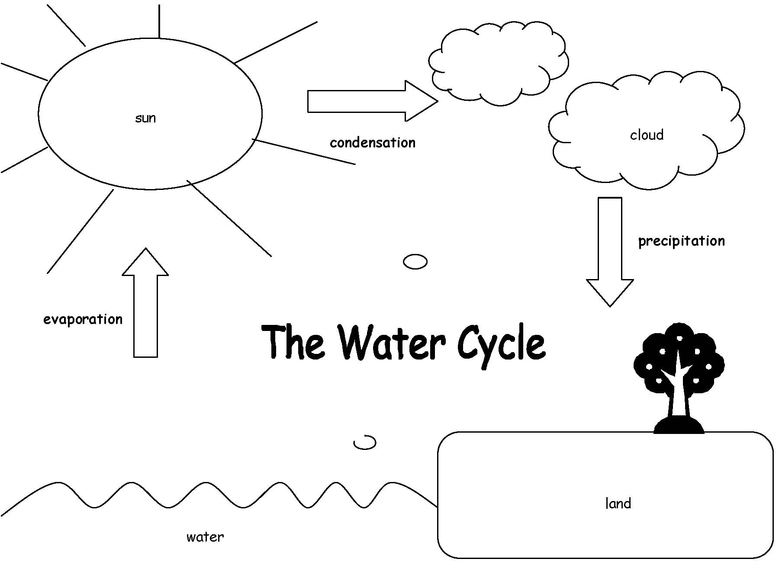

Water Cycle Cut-outs
Condensation
Evaporation
Precipitation
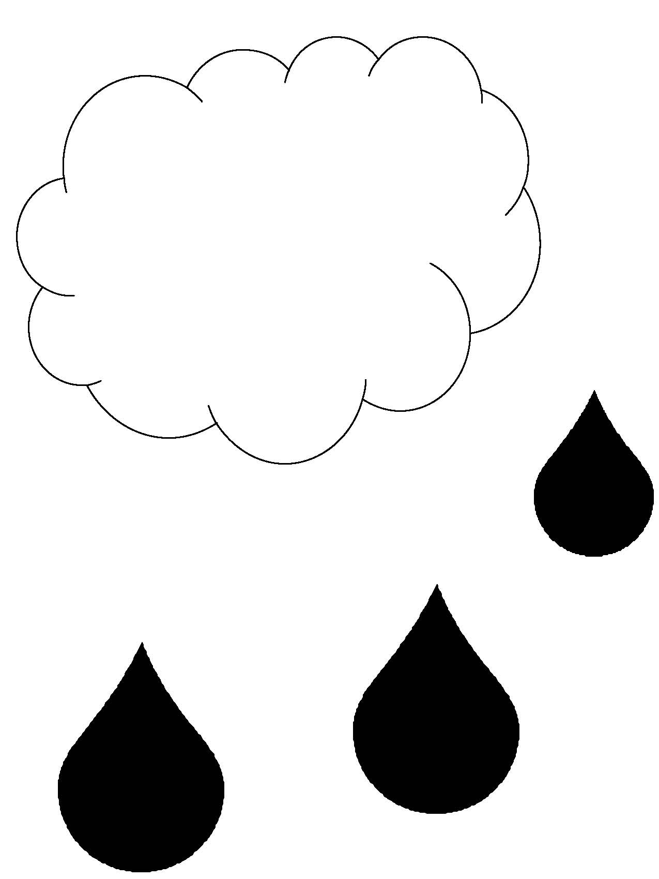
Water Cycle Arrows
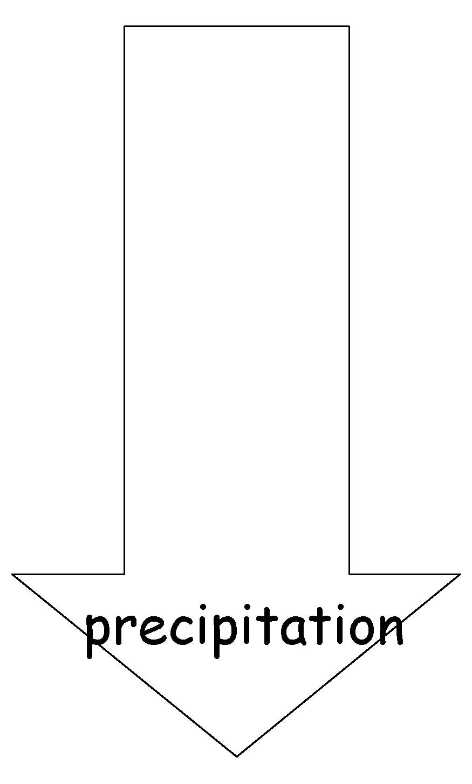

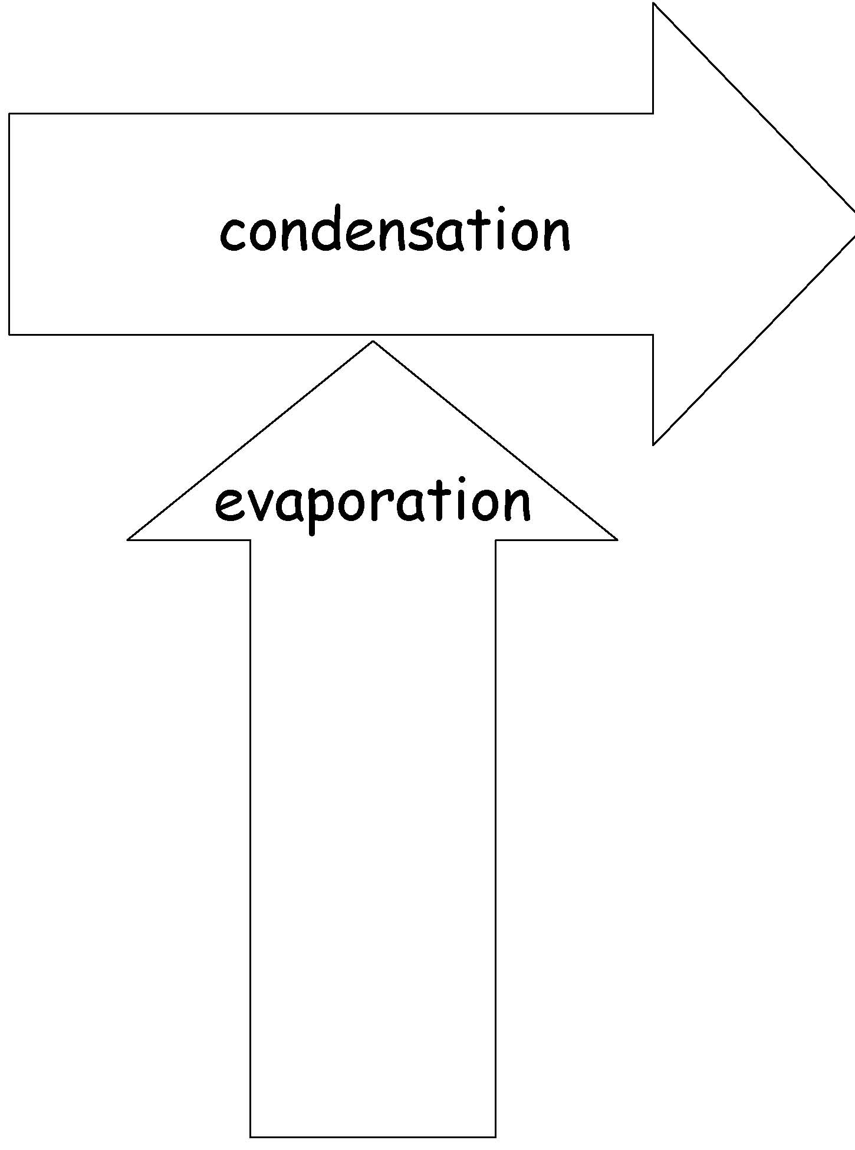

Appendix 3- Cotton water use
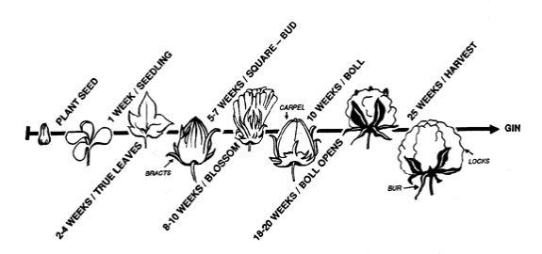

Appendix 4 - Crop water requirements
Crop | Average irrigation requirement (megalitres/ ha)
Rice | 12.3
Lucerne for hay | 10
Sweet corn | 8
Asparagus | 8
Watermelon | 8
Tomatoes | 8
Maize | 7.15
Cotton | 6.3
Soybeans | 6
Sugar cane | 5
Pasture for grazing | 4

Appendix 5 - Cotton and water facts
- Australia’s cotton industry is considered the most water-efficient in the world, producing “more crop per drop” than any other nation at two and a half times the world’s average yields.
- Appropriate varieties, a massive research effort, use of the latest technologies and cutting edge farm practices all combine to produce Australian cotton fibre that is farmed with less water per hectare than ever before.
- The Australian cotton industry has achieved a 40% increase in water productivity over the last decade. (source: The Australian Cotton Water Story, 2012)
- Australia’s cotton growers have improved their water use efficiency by 3-4% per year since 2003. (source: Third Australian Cotton Industry Environmental Assessment, September 2012)
- Australian cotton growers have almost doubled their Irrigation Water Use Index from 1.1 megalitres per bale in 2000-01 to 1.9 megalitres per bale in 2009-10. (source: The Australian Cotton Water Story, 2012)
- In 2011-12 about 20% of the cotton crop was rain-grown, the rest irrigated.
- Cotton uses about the same amount of water as other summer crops, is drought and heat tolerant and uses less water than rice, maize, soybeans and many vegetable crops.
- Cotton’s average irrigation requirement is 5.2 megalitres per hectare (5.2 ML/ha), compared to rice (10.1ML/ha), nurseries, cut flowers and turf (4.2 ML/ha) and fruit and nut trees. (4 ML/ha) (source: ABS Water Use on Australian Farms 2010-11)
- Pasture for grazing accounted for the greatest amount of irrigated land (538,000 hectares) in Australia in 2010–11, with the volume of irrigation water applied representing 27% of the national total. (source: ABS Water Use on Australian Farms 2010-11)
- Cotton growing accounted for nearly 40% of total water extracted in the Murray-Darling Basin in 2009-10. (source: ABS Water Use on Australian Farms 2010-11)
- Cotton is the lifeblood of many regional communities, employing 8,000 Australians in Northern NSW and Southern QLD alone.
- Each gigalitre of water used for cotton production results in 1.3 direct jobs and generates $500,000 in gross value agricultural production. (source: Stubbs Report, 2012)
- Cotton is an ideal crop for Australia’s extremely variable climate where in some years water is plentiful and other years suffer from drought. Cotton is an ideal crop because it is only planted when there’s water available. For example, the 2007/08 cotton crop was the smallest in 30 years due to a lack of available water.
- Cotton is an efficient plant, with the latest industry data showing approximately 63% of all water is used by the crop.
- Irrigation water for agriculture is used on the highest value crops. Farmers choose to”spend” their water entitlements on the crops that deliver the best return per unit of water; in many areas that crop is cotton.
- Cotton growers have significantly improved their irrigation systems and practices in the last five years (Source: 2011 Cotton Grower Survey, CRDC)
- Most cotton growers have what are termed “low security” water licences, which means they only get to access their share of the water once the needs of towns, stock and domestic use and the environment are met. This means the percentage of water that cotton growers can access varies greatly from year to year depending on availability.
- Cotton growers can only access water from rivers under a strict set of government rules, when it is available. When there’s no water, there’s no cotton. In their ‘natural’ state, the rivers located in the southern half of Australia experience more variable flows than virtually any other rivers in the world. Between 1885 and 1960, history shows the Darling River stopped flowing at Menindee on 48 occasions—well before irrigation existed on the river or its tributaries.
- Cotton growers are using a range of techniques to constantly improve water use efficiency including in-field moisture monitoring, reducing evaporation, scheduling irrigations, improved soil health and new irrigation techniques such as overhead sprinklers and drip irrigation.

Appendix 6- Cotton farm layout
(Source: The Workboot Series: Cotton (1997), pg 62)
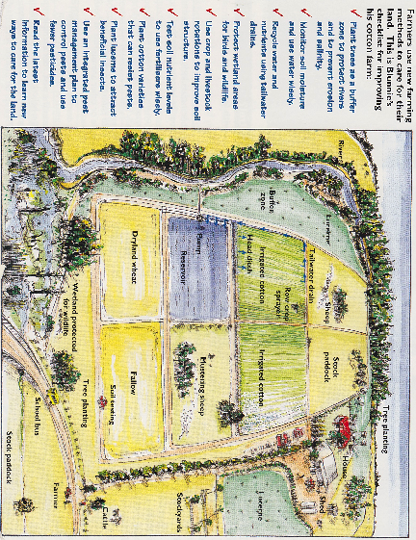

Appendix 7- Collaborative learning teams
(Source: Watch It Grow, Primary Connections (2011) pp 59-62, 69)

Introduction
By working in collaborative teams students are able to:
  - Communicate and compare their ideas with one another
  - Build on one another’s ideas
  - Discuss and debate these ideas
  - Revise and think through their reasoning
  - Present their final team understanding through multi- modal representations.
Students need to be taught how to work collaboratively. They need to work together regularly to develop effective group learning skills.

Team structure
The first step towards teaching students to work collaboratively is to organize the team composition, roles and skills. Use the following ideas when planning collaborative learning with your class:
  - Assign students to teams rather than allowing them to choose partners.
  - Vary the composition of each team. Give students opportunities to work with others who might be of a different ability level, gender or cultural background.
  - Keep teams together for two or more lessons so that students have enough time to learn to work together successfully.
  - If you cannot divide the students in your class into teams of three, form two teams of two students rather than one team of four. It is difficult for students to work together effectively in larger groups.
  - Keep a record of the students who have worked together as a team so that by the end of the year each student has worked with as many others as possible.

Team roles
Students are assigned roles within their team. Each team member has a specific role but all members share leadership responsibilities. Each member is accountable for the performance of the team and should be able to explain how the team obtained its results. Students must therefore be concerned with the performance of all team members. It is important to rotate team jobs each time a team works together so that all students have an opportunity to perform different roles.
Each member of the team should wear something that identifies them as belonging to that role, for example, a colour- coded peg, badge or wristband. This makes it easier for you to identify which role each student is doing and it is easier for the students to remember what they and their team members should be doing.
The teams consist of three students - Director, Manager and Speaker.

Manager
The Manager is responsible for collecting and returning the team’s equipment. The Manager also tells the teacher if any equipment is damaged or broken. All team members are responsible for clearing up after an activity and getting the equipment ready to return to the equipment table.

Speaker
The Speaker is responsible for asking the teacher or another team’s Speaker for help. If the team cannot resolve a question or decide how to follow a procedure, the Speaker is the only person who may leave the team and seek help. The Speaker shares any information they obtain with team members. The teacher may speak to all team members, not just to the Speaker. The Speaker is not the only person who reports to the class; each team member should be able to report on the team’s results.

Director
The Director is responsible for making sure that the team understands the team investigation and helps team members focus on each step. The Director is also responsible for offering encouragement and support. When the team has finished, the Director helps team members check that they have accomplished the investigation successfully. The Director provides guidance but is not the team leader.

Team skills
Students will practise the following team skills throughout the year:
  - Move into your teams quickly and quietly
  - Speak softly
  - Stay with your team
  - Take turns
  - Perform your role
To help reinforce these skills, display enlarged copies of the team skills chart in a prominent place in the classroom.

An elaboration of the PrimaryConnections 5Es teaching and learning model Adapted from Bybee (1989) The Australian Academy of Science Primary Connections

